**Lab 3 Assignment**

**Nagulapati, Rohith Kumar,16**

**Nandigam, Nageswara Rao,17**

1. **Application built using Clarifai API:**

**Objective:** The objective of the application is to get fuzzy classification for the selected image using Clarifai API

**Code snippet for handling predictions from Clarifai:**

**final** List<ClarifaiOutput<Concept>> predictions = response.get();  
   
 **if** (predictions.isEmpty()) {  
 showErrorSnackbar(R.string.***no_results_from_api***);  
 **return**;  
 }  
 **adapter**.setData(predictions.get(0).data());  
 **imageView**.setImageBitmap(BitmapFactory.*decodeByteArray*(imageBytes, 0, imageBytes.**length**));  
}

**Code Snippet for adding clarifai key to the application:**



**Output:**

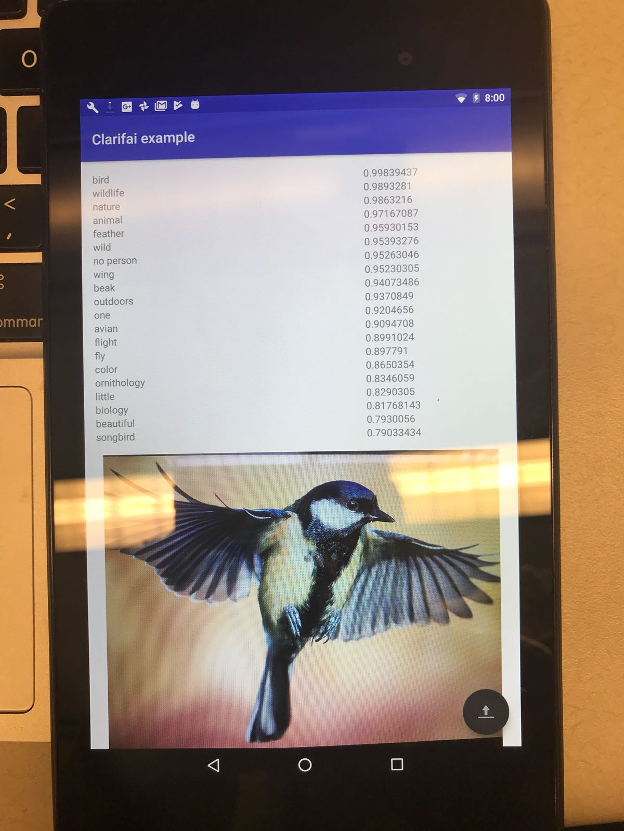 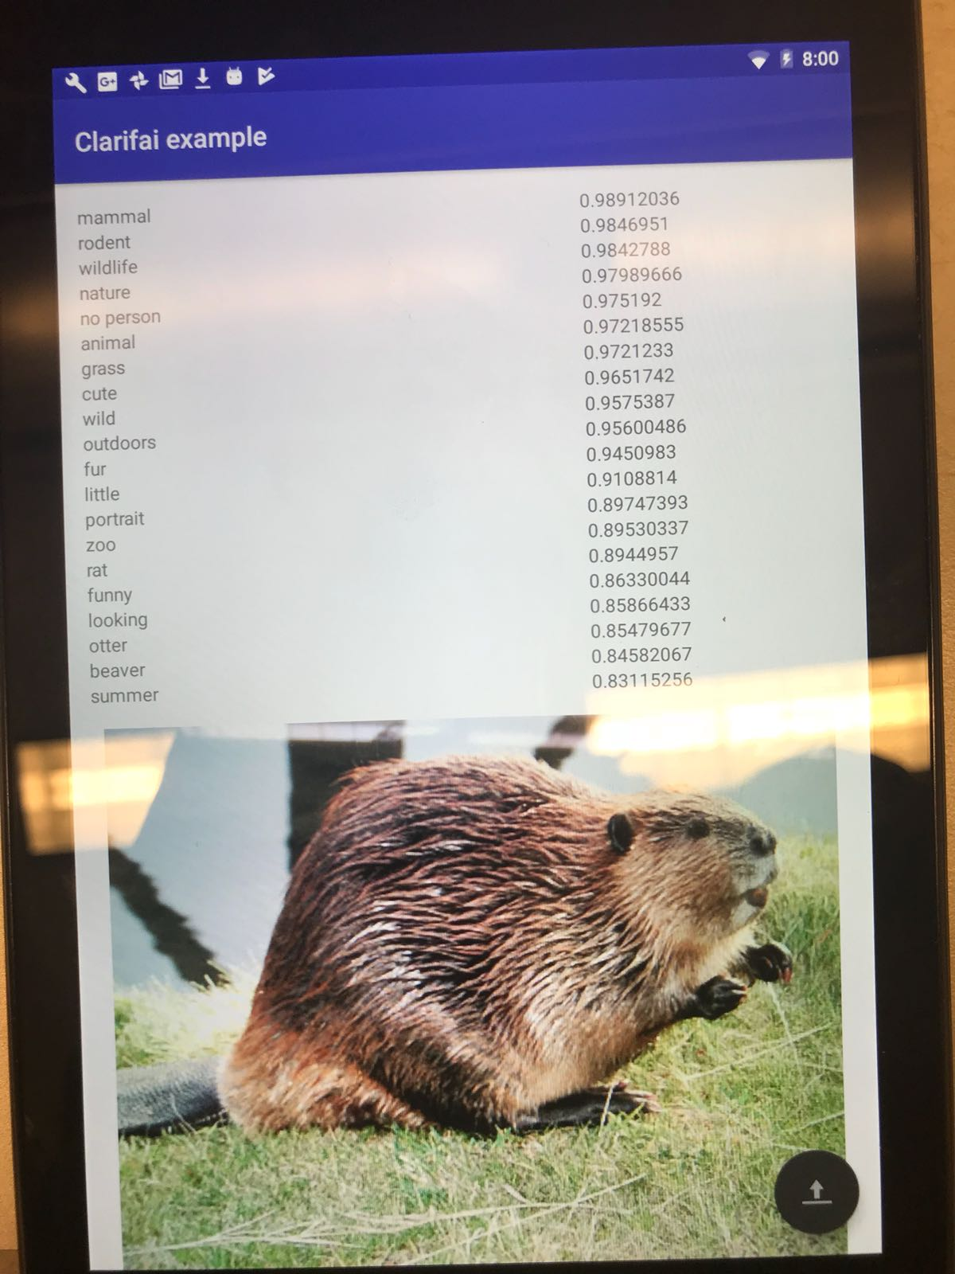

1. **Application built using Spark API**

**Objective:** Application to demonstrate our own fuzzy classification results for various classification algorithms like Naïve Bayes, Decision Tree and Random Forest

**Code snippet to show how to display fuzzy prediction results:**

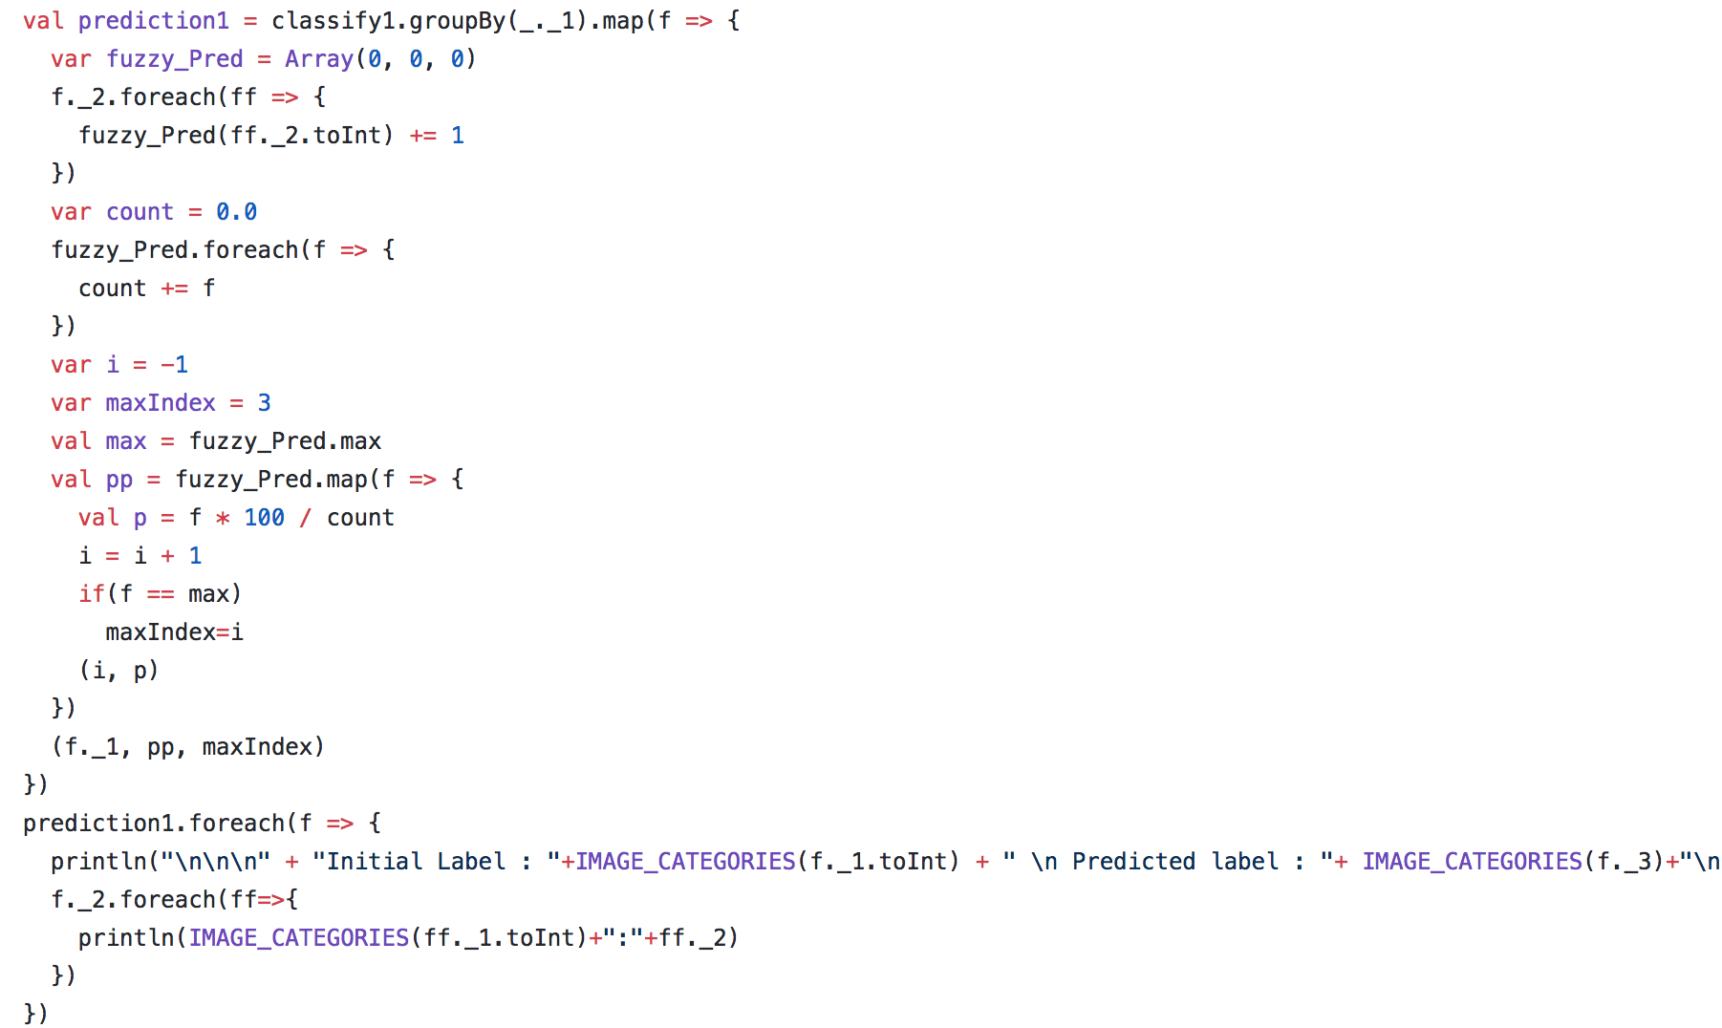

**Decision Tree:**

Code snippet to build Decision Tree model with the below parameters

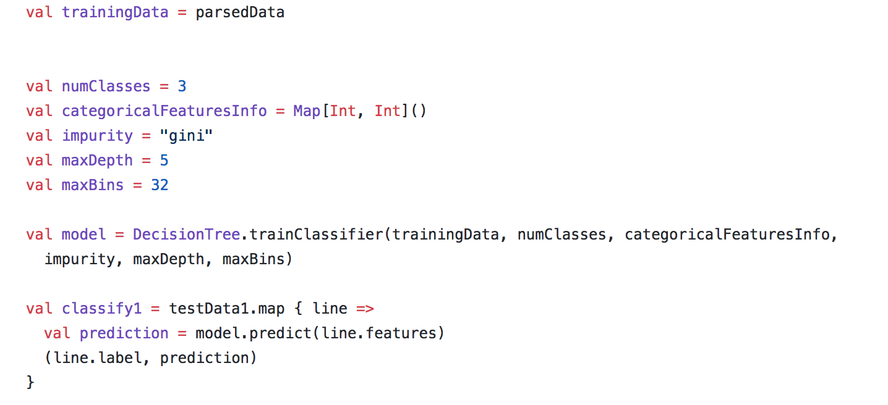

**Decision Tree Fuzzy Classification Results:**

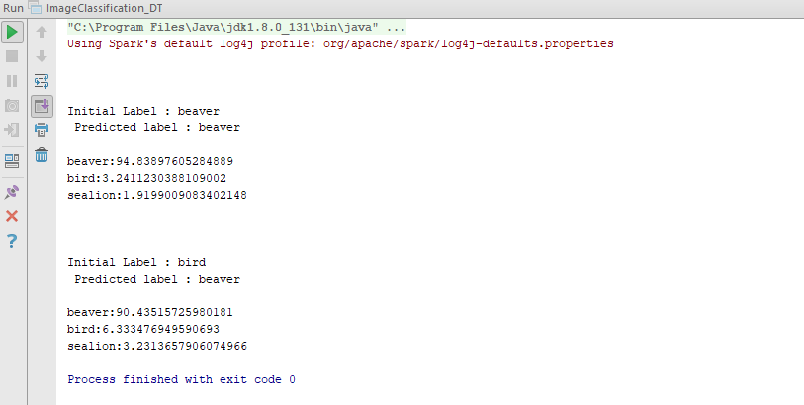

**Naïve Bayes:**

Code snippet to build Naïve Bayes model with the below parameters

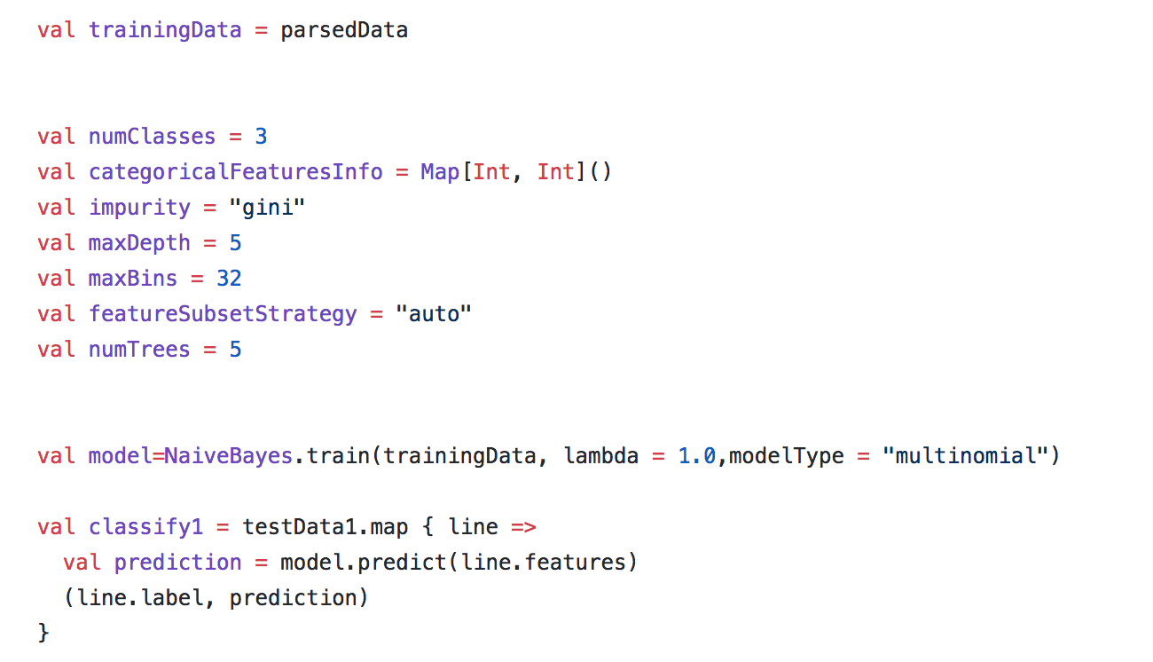

**Naïve Bayes Fuzzy Classification Results:**

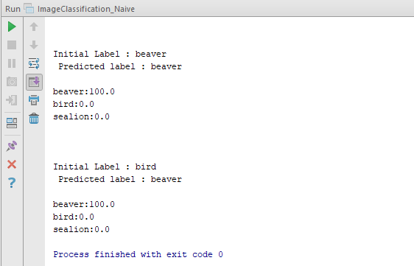

**Random Forest:**

Code snippet to build Random Forest model with the below parameters

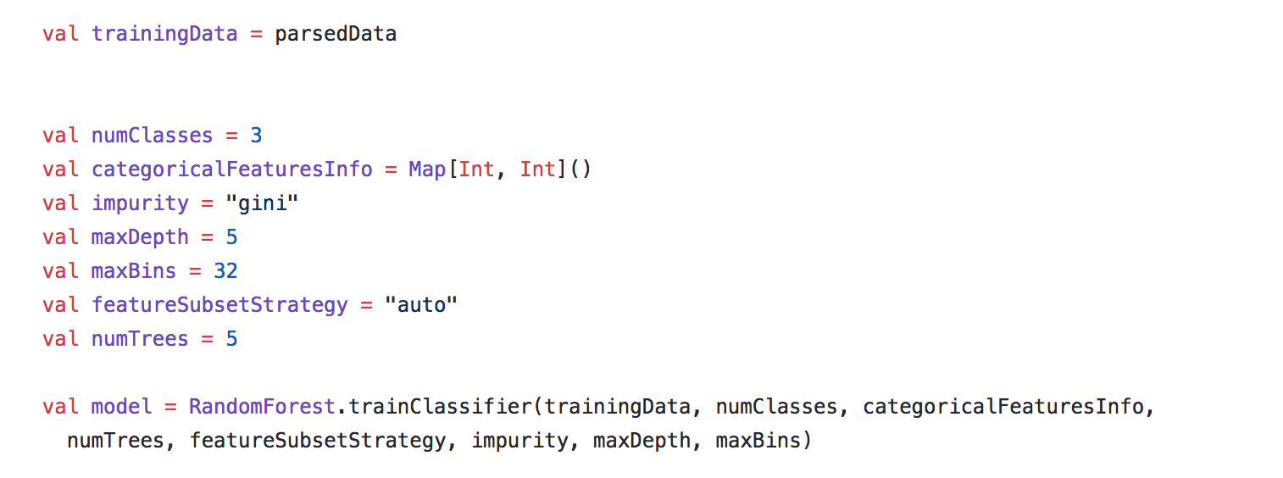

**Random Forest Fuzzy Classification Results:**

